Risk-based risk prediction AI engine

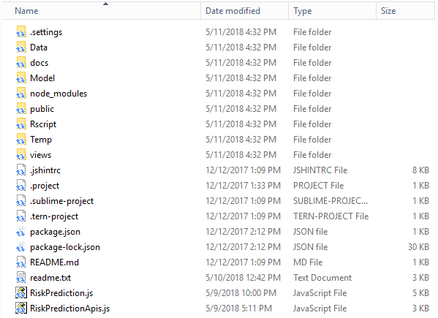

Data/

* Includes the collected from USC’s software engineering courses and open source projects (github).

docs/

* Includes the documentations for research methods and usage of the tool.

Model/

     - Includes the trained machine learning model (neural network) to predict risk.

public/

* Includes the materials for the rest api and web-based demo.

Rscript/

* Includes the R script to train machine learning model (based on neural network).

Temp/

* Used to contain the temporary files that are generated during the executions of the scripts.

Views/

* Include the web page template for the web-based demo.

Readme.txt

* Some configuration and setting up manual.

RiskPrediction.js

* The script used to execute the trained ML model for risk prediction.

RiskPredictionApis.js

* The API used to provide access to the trained ML model for risk prediction.